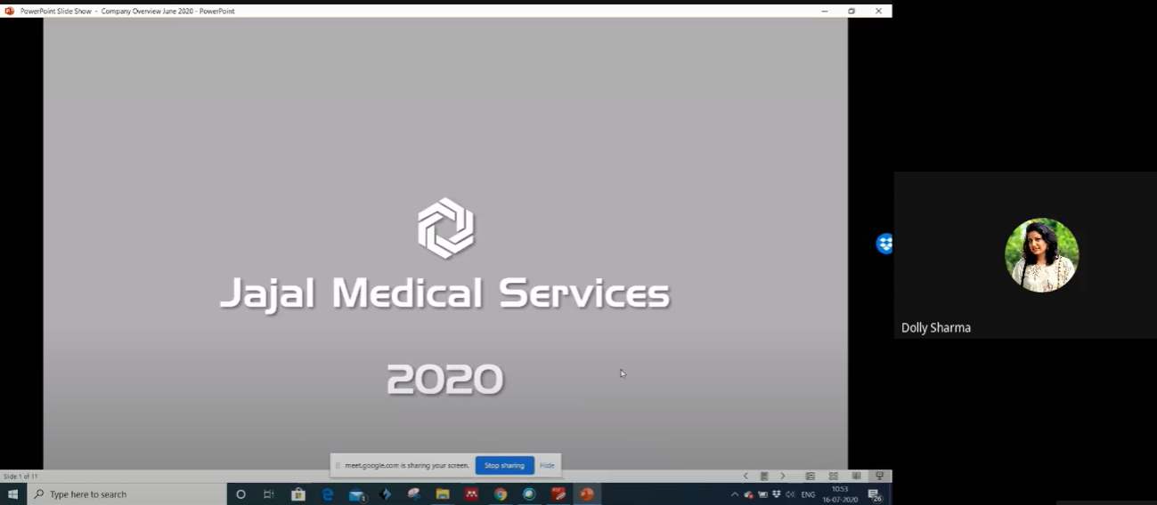

Figure 1: July 16, 2020 - Mrs. Dolly Sharma felicitating the presenter Mr. Ravikant kamal during the commencement of Online Workshop

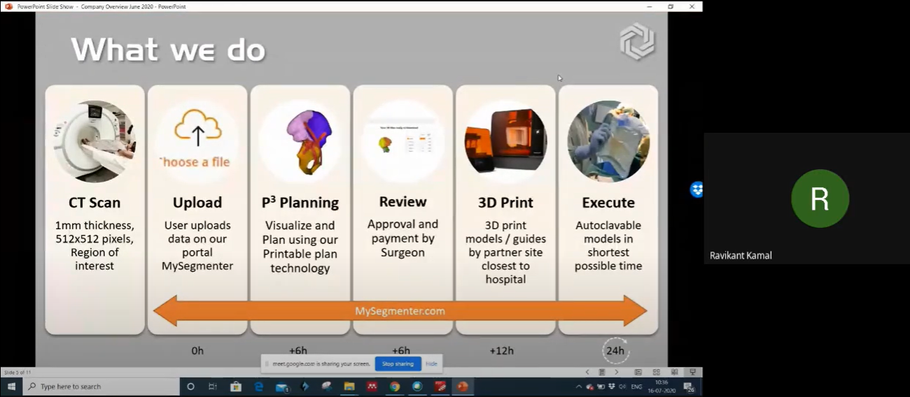

Figure 2: July 16, 2020 - Mr. Ravikat Kamal presnting on the topic Application of 3D post processing via Google meet

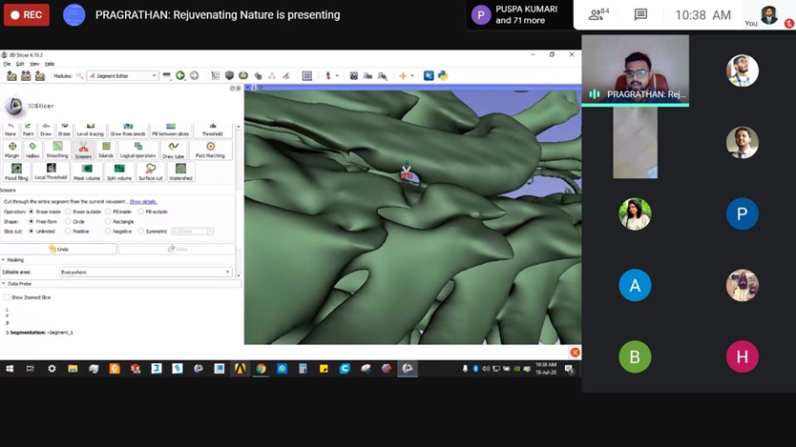

Figure 3: 17 July, 2020 - Mr. Dhaval Trivedi presenting on th Online workshop - Application of 3D-slicer

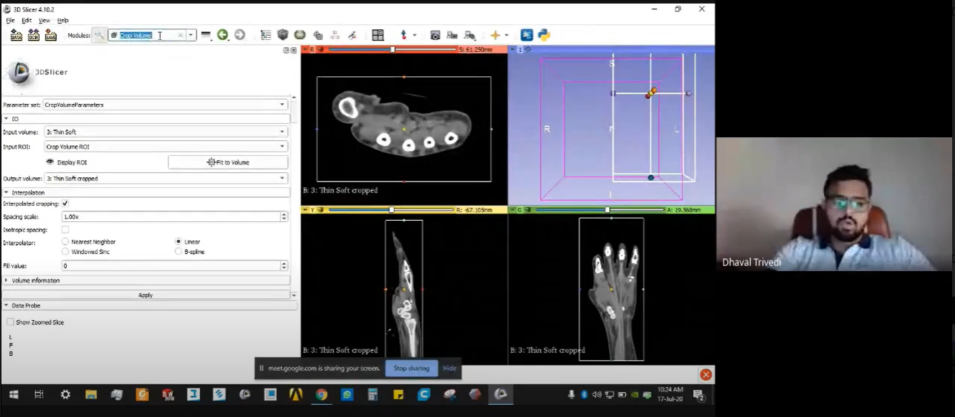

Figure 4: 18 July,2020 - Mr. Dhaval Trivedi presenting on the Online Workshop - Basic tools and Handling of 3D slicer